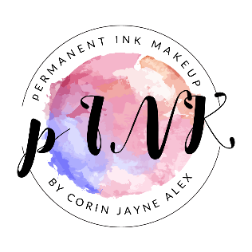
PERMANENT MAKEUP PRETREATMENT ADVICE AND CONSIDERATIONS
If you are having a lip procedure and have had a history of cold sores or breakout with cold sores or mouth ulcers, the procedure is likely to stimulate the problem. You can minimize or prevent an outbreak by obtaining prescription medication for up to 10 days prior and 10 days after the procedure. (Please try not to use the generic brands if possible). In the event of an outbreak, the use of ice and diligent use of medicine may minimize the episode. The sores may cause the loss of pigment in the end result.
Allergy testing is recommended for red pigments one week before the planned procedure. Persons with very sensitive skin and who have a history of allergic reactions should undergo an allergy test prior to a procedure.
Delicate areas may swell slightly or become red. It is advised not to make social plans for the same or next day. Lip procedures may appear slightly swollen and dry for up to 7 days. The use of aftercare ointment will reduce the dryness.
Bring your normal makeup to your initial consultation appointment. Bring your favourite coloured eyebrow pencils and lipsticks to consultation.
Eyebrows that are usually dyed should be done 2 weeks before and 4 weeks post treatment.
Brow enhancing conditioning products must be stopped 10-12 weeks before any brow procedure.
Do not use aspirin or ibuprofen for 48 hours prior to the procedure and no fish oils for 7 days prior . No caffeine or alcohol 24 hours before appointment and no exercise 24 hours prior. These precautions will minimize pain and bleeding leading to better healed results.
Do not sunbathe or tan at least one week before the procedure. No facial peels or microdermabrasion treatments 2 weeks before. No sunbeds for 3-4 weeks post treatment.
No Retin A or retinol products 2-4 weeks before procedures.
Botox should be done a minimum of 3 weeks before. If you get them regularly and are due to have it, get a natural reading of where your brows go first then do injections after two weeks.
LIP BLUSHING – please use a gentle lip scrub once a day for 10 days before followed by a moisturising lip balm to keep the lip skin soft, making it easier for me to implant piment with ease and the most comfort.
These pre treatment and post treatment recommendations will assist in a safe and more pleasant experience during and after your new makeup procedures.
I look forward to making this experience a good one and enhancing your natural beauty with permanent cosmetics.
Blessings,
p INK Makeup

