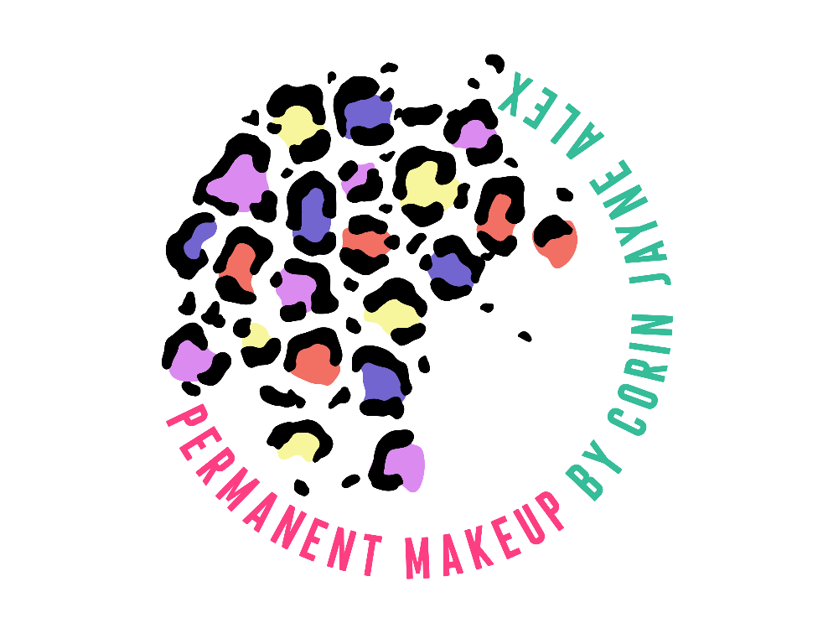
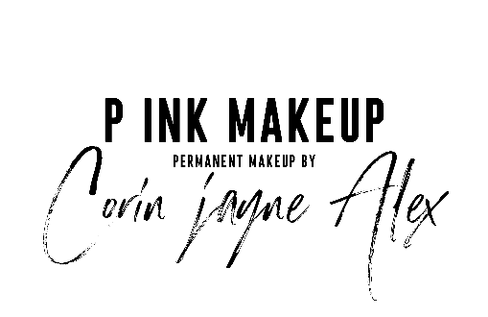

Post Care Instructions

Yay you finally have your new permanent makeup!
For the first few days your permanent makeup will appear very intense, don’t worry this will subside during the healing process. The pigment is just oxidising, which makes the surface appear much darker. Brows fade 20/30% and lips will fade 50/70%.
During the first 72 hours you PMU will be at its darkest. As the healing goes on the dark surface will begin to flake off. By the second week your PMU will be considerably lighter and softer so just ride it out because it will come back through, I promise it will be worth the wait!
Please gently cleanse the treated area with wash and a cotton round and pat dry 2-3 times a day for the first 2 days, on day 3 continue to wash and apply a thin layer of healing balm, do this for 14 days just be careful not to pull away scabbing. please keep the area otherwise dry until all flaking has come away (Don’t pick!). Once the flaking has come away completely, continue to apply the healing balm to help aid the last bit of healing. For Lips apply your aftercare balm when they begin to feel a little dry and avoid hot drinks and salty/spicy food for the first 4 days.
During the healing process, it is extremely important to be attentive to the treated area for the best healed results. It is extremely important and detrimental to your healed results that you don’t pick or pull away the flaking as this will cause pigment to be lifted from the healing skin. It can also lead to scarring.
As your brows are now looking patchy you may think you’ve lost some colour and they are looking uneven or even different shapes. The colour will come back through, at the moment you skin is acting like a veil over the top of the pigment whilst it is regenerating new cells. Whilst your skin is in this process it is also can distort the shape, again this will all be okay when the healing is over.
Please avoid exercise for 7 days post procedure. The salt in your sweat will lift pigment out of the skin like a saline removal solution. Once your skin is intact and stopped flaking you can resume as normal.

Please also avoid wearing makeup around the area. Makeup brushes and sponges will contain bacteria which you want to avoid around a fresh wound. Using makeup can lead to infection followed by poor retention of your PMU.

Please avoid the use of astringents and exfoliants or any products containing the following: Retinol Acids, Benzoyl Peroxides, Salicylic Acids, Alpha Hydroxyl Acids (AHA), Beta Hydroxyl Acids (BHA), Lactic Acids or Mandelic Acids. Applying any of the above products can also cause pigment to migrate under the skin.

6 weeks post procedure it is recommended that you return for a follow up appointment, this is a review for me to see how your PMU has healed, which also offers a complementary wax on brows. You will have already been booked in for a review to determine how long it will take if a touch up is needed. So if there are any parts of your PMU that has not retained pigment don’t worry there is the offer of a touch up at the discounted price of £50 for your second session no matter how much work is required. If you fail to book for your touch up within the 8 week period your touch up will be the cost of an annual boost.

The longevity of your PMU will be dependent upon your skin type and also your lifestyle. For example, someone with super oily skin or someone who exercises regularly will require an annual colour boost sooner than someone with drier, normal skin.

If you have any further questions or concerns that are not covered in this document, regarding your PMU please do not hesitate to contact p INK Make Up.
To ensure the best results from your PMU and to aid your skin in proper healing it is important you follow this aftercare. Also be aware that you should keep your PMU out of direct sunlight for 14 days. Once fully healed you may apply a strong SPF to further protect the area.

Stages of Your PMU
